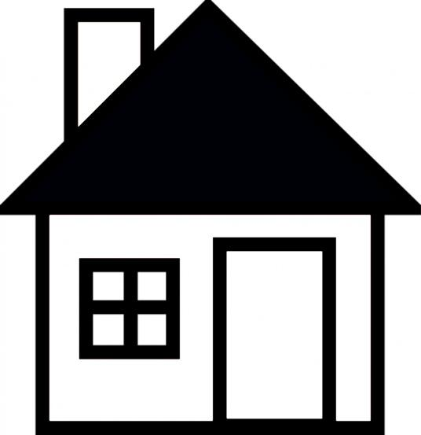Elizabeth Rose’s Cleaning Services

Charge by the hour 40/ hr

KITCHEN

* Oven interior/exterior (upon request)
* Fridge interior/exterior (upon request)
* Cabinet’s interior/exterior
* Dust and wipe all light fixtures
* Wipe back splash
* Windows, exterior and sills
* Light switches
* High touch areas such as door handles
* Chairs
* Clean sink
* Clean kitchen table
* Vacuum and mop floors

LIVING ROOM

* Tidy
* Remove cushions and vacuum all furniture
* Door, door frames, trim and baseboards
* Door knobs
* Wipe TV and entertainment devices
* Window interior, sills, tracks
* Spot wipe walls
* Wipe light switches
* Light fixture
* Blinds
* Vacuum and mop floors

BATHROOMS

* Ceiling fan cover
* Light fixtures
* Wipe the exteriors of cabinetry
* Windows interior, sills, and tracks
* Baseboards
* Spot wipe walls
* Toilets inside and out
* Shower doors and fixtures
* Bathtubs and fixtures
* Counters
* Mirrors
* Empty and clean garbage can
* Clean and disinfect sink
* Polish towel rack
* Polish toilet paper holder
* Wipe down door, knobs, door frames
* Vacuum and wash floors
* Tile grout

BEDROOMS

* Tidy
* Wipe ceiling fan
* Window interior, sills, tracks
* Doors, door frames, trim, and baseboards
* Cabinetry/shelving
* Light fixtures
* Dust and wet wipe all hard surfaces
* Change sheets and make the bed (upon request)
* Empty and clean garbage cans
* Spot wipe walls and light switches
* Vacuum floors and mop floor

ALL AREAS OF THE HOUSE

* Dust surfaces
* Dust and wipe furniture tops
* Dust and wipe baseboards
* Wipe chair rails, blinds, and door panels
* Ceiling fans
* Vacuum all floors
* Mop all non-carpeted floors
* Vacuum furniture
* Dust picture frames
* Dust lamps and lamp shades
* Dust and wipe all décor items
* Clean mirrors
* Empty all trash